Sound Rendering Engine
This is an example of a flexible Sound Rendering Engine (SRE) developed with Max/MSP, controlled with OSC messages sent from BlenderVR via its OSC API. Said SRE is open source, built as to allow simple modification of its core elements (e.g. spatialization engine) to be shaped to the needs of various VR architectures (ambisonic, binaural, WFS, VBAP, etc.).
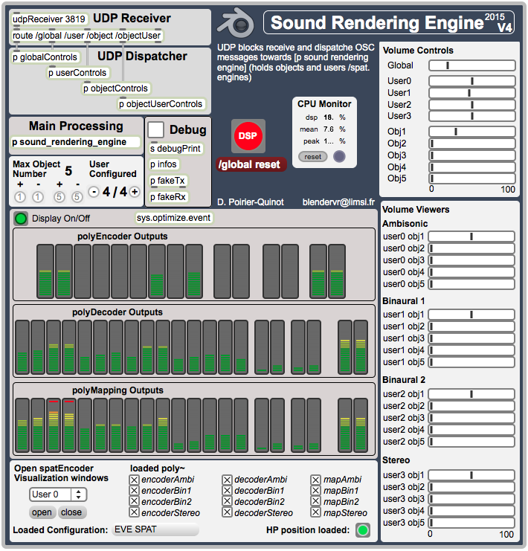
download: BlenderVR Sound Rendering Engine version 1.0 (.zip)
Features:
- Binaural, Ambisonic, VBAP and Stereo rendering, based on Open Source libraries.
- Compatible with the SPAT software from IRCAM.
- Simultaneously render up to two binaural channels (tracked BlenderVR users) + 1 Multi-Speakers (e.g. Ambisonic, VBAP) channel + 1 Stereo channel.
- Any number of sound objects.
- Transparent adaptation of the SRE to the current architecture (speaker array, headset, etc.): design your own components (max patches) to be dynamically loaded according to the current architecture (single software, architecture-specific sound rendering).

